ANALYSTLAB AFRICA
INTERNSHIP
SALES DATA SAMPLE
SQL QUERY ANALYSIS REPORT
Week 3 Deliverable

Prepared by
Akhimien Evelyn Ilobekemen
June 2026

Table of Contents
Table of Contents 1
1. Introduction 1
2. Dataset Overview 1
Query A: Total Record Count 1
Query B: Distinct Entity Counts 1
3. Filtering and Sorting (SELECT / WHERE / ORDER BY) 1
Query 1: Shipped Orders from the USA, Most Recent First 1
4. GROUP BY and Aggregate Functions 1
Query 2: Revenue, Average Line Value, and Line Items per Product Line 1
Query 3: Total Revenue, Average Line Value, and Line Items (Overall) 1
5. GROUP BY with HAVING 1
Query 4: Customers Whose Lifetime Spend Exceeds $100,000 1
6. Revenue, Quantity, and Status Breakdowns 1
Query 5: Top 10 Countries by Revenue 1
Query 6: Delivery Status of Goods 1
Query 7: Total Quantities Shipped in Each Country 1
Query 8: Quantities Cancelled and Disputed in Each Country 1
7. Time-Based Revenue Analysis 1
Query 9: Total Revenue by Year 1
Query 10: Total Revenue by Month 1
8. Order Value and Volume Metrics 1
Query 11: Average Order Value 1
Query 12: Annual Revenue and Order Volume 1
Query 13: Monthly Sales Performance Breakdown 1
9. Product and Customer Performance 1
Query 14: Performance by Product Line 1
Query 15: Top 10 Best-Selling Products by Revenue 1
Query 16: Top 10 High-Value Customers 1
10. Geographic and Operational Summary 1
Query 17: Revenue Breakdown by Country 1
Query 18: Order Fulfillment Status 1
Query 19: Deal Size Distribution 1
11. Summary of Key Findings 1
12. Conclusion 1

1. Introduction
This report documents the Structured Query Language (SQL) analysis carried out in Week 3 of the AnalystLab Africa internship, using the Sales Data Sample dataset. The dataset records individual order line items for a wholesale distributor of scale-model vehicles, including order details, product line, customer, country, deal size, and revenue figures.
The objective of this exercise was to practice core SQL techniques — filtering and sorting, aggregate functions, GROUP BY with HAVING, and multi-dimensional breakdowns in order to answer realistic sales and business performance questions.
Each query below presents the business question, the SQL used to answer it, a screenshot of the query output, and a short insight describing what the result tells us about sales performance.

2. Dataset Overview
The table sales_data_sample contains one row per order line. Before performing deeper analysis, the dataset's overall size and the number of distinct orders, customers, products, and countries were established as baseline figures.

Query A: Total Record Count
Business Question
How many order line records exist in the dataset?
SQL Query
SELECT COUNT(*) AS total_records
FROM sales_data_sample;
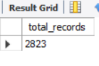
Figure A: Total number of records in the dataset
Insight: The dataset contains 2,823 order line records, giving a moderately sized dataset suitable for granular revenue and product analysis.

Query B: Distinct Entity Counts
Business Question
How many unique orders, customers, products, and countries are represented?
SQL Query
SELECT
COUNT(DISTINCT ORDERNUMBER) AS Unique_orders,
COUNT(DISTINCT CUSTOMERNAME) AS Unique_customer,
COUNT(DISTINCT PRODUCTCODE) AS Unique_product,
COUNT(DISTINCT COUNTRY) AS Unique_countries
FROM sales_data_sample;
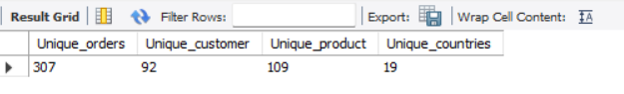
Figure B: Distinct counts of key business entities
Insight: The 2,823 line items roll up to 307 unique orders, 92 unique customers, 109 unique products, and 19 countries — confirming each order spans multiple line items on average (about 9 lines per order).

3. Filtering and Sorting (SELECT / WHERE / ORDER BY)

Query 1: Shipped Orders from the USA, Most Recent First
Business Question
Which orders shipped to the USA have been marked as Shipped, ordered from most to least recent?
SQL Query
SELECT ordernumber, quantityordered, orderlinenumber, orderdate, status, country
FROM sales_data_sample
WHERE COUNTRY = 'USA'
AND status = 'shipped'
ORDER BY ORDERDATE DESC;
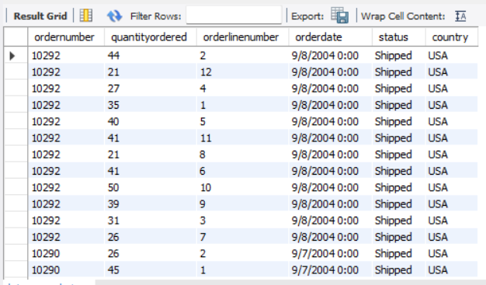
Figure 1: Shipped USA orders, sorted by order date (most recent first, top rows shown)
Insight: Filtering on country and status together isolates only completed USA shipments, and sorting by ORDERDATE DESC surfaces the latest shipping activity first — useful for a quick check on recent fulfillment in the largest single market.

4. GROUP BY and Aggregate Functions

Query 2: Revenue, Average Line Value, and Line Items per Product Line
Business Question
What is the total revenue, average order line value, and number of distinct product lines, broken down by product line?
SQL Query
SELECT
SUM(Revenue) AS TotalRevenue,
ROUND(AVG(orderlinenumber), 2) AS avg_line_value,
COUNT(DISTINCT productline) AS Line_Items
FROM sales_data_sample
GROUP BY PRODUCTLINE;
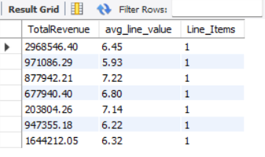
Figure 2: Revenue and line-value metrics, grouped by product line
Insight: Revenue varies widely across product lines, from roughly $204K up to $2.97M per group, showing product line is a major driver of revenue concentration in the catalogue.

Query 3: Total Revenue, Average Line Value, and Line Items (Overall)
Business Question
What are the same metrics calculated across the entire dataset, with no grouping?
SQL Query
SELECT
SUM(Revenue) AS TotalRevenue,
ROUND(AVG(orderlinenumber), 2) AS avg_line_value,
COUNT(DISTINCT productline) AS Line_Items
FROM sales_data_sample;
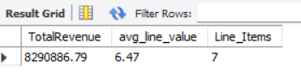
Figure 3: Overall revenue and average line value across all records
Insight: Total revenue across the full dataset is $8,290,886.79, with 7 distinct product lines in total — this single-row summary provides the baseline that the product-line breakdown in Figure 2 adds up to.

5. GROUP BY with HAVING

Query 4: Customers Whose Lifetime Spend Exceeds $100,000
Business Question
Which customers have spent more than $100,000 in total, ranked from highest to lowest?
SQL Query
SELECT CUSTOMERNAME,
ROUND(SUM(Revenue), 2) AS lifetime_spend
FROM sales_data_sample
GROUP BY CUSTOMERNAME
HAVING SUM(Revenue) > 100000
ORDER BY lifetime_spend DESC;
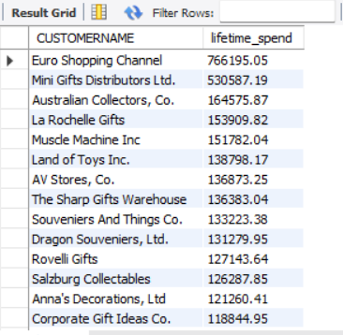
Figure 4: High-value customers exceeding $100,000 in lifetime spend
Insight: Euro Shopping Channel is by far the top customer at $766,195.05 — roughly 44% more than the second-place Mini Gifts Distributors Ltd. ($530,587.19) — making it the single most important account to retain.

6. Revenue, Quantity, and Status Breakdowns

Query 5: Top 10 Countries by Revenue
Business Question
Which 10 countries generate the most revenue?
SQL Query
SELECT COUNTRY, SUM(REVENUE) AS total_revenue
FROM sales_data_sample
GROUP BY COUNTRY
ORDER BY total_revenue DESC
LIMIT 10;
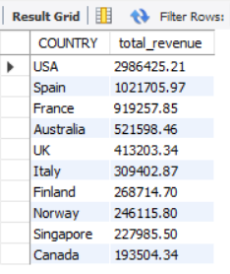
Figure 5: Top 10 countries ranked by total revenue
Insight: The USA leads with $2.99M, nearly triple the second-ranked country, Spain ($1.02M) — confirming the USA as the dominant market by a wide margin.

Query 6: Delivery Status of Goods
Business Question
How many units fall under each order status (Shipped, Cancelled, Disputed, etc.)?
SQL Query
SELECT SUM(QUANTITYORDERED) AS total_quantity, STATUS
FROM sales_data_sample
GROUP BY STATUS;
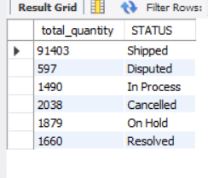
Figure 6: Total quantity ordered, grouped by delivery status
Insight: 91,403 units were successfully Shipped against a combined 2,038 Cancelled and 597 Disputed units — less than 3% of shipped volume — indicating a healthy, low-friction fulfillment process.

Query 7: Total Quantities Shipped in Each Country
Business Question
Among shipped orders only, how is shipped quantity distributed across countries?
SQL Query
SELECT SUM(QUANTITYORDERED) AS total_quantity, STATUS, COUNTRY
FROM sales_data_sample
WHERE STATUS = 'Shipped'
GROUP BY STATUS, COUNTRY;
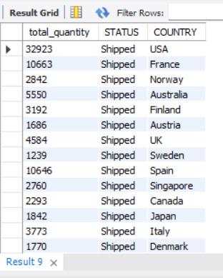
Figure 7: Shipped quantity by country
Insight: The USA again leads shipped volume with 32,923 units, followed by Spain (10,646) and France (10,663) — broadly consistent with the revenue ranking seen earlier, confirming volume and revenue leadership both sit with the same top markets.

Query 8: Quantities Cancelled and Disputed in Each Country
Business Question
Which countries have the highest cancelled or disputed quantities?
SQL Query
SELECT SUM(QUANTITYORDERED) AS total_quantity, STATUS, COUNTRY
FROM sales_data_sample
WHERE STATUS IN ('Disputed', 'Cancelled')
GROUP BY STATUS, COUNTRY;
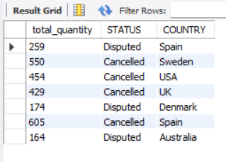
Figure 8: Cancelled and disputed quantities by country
Insight: Spain shows the highest Cancelled quantity (605 units) and also appears under Disputed (259 units), making it the country with the most fulfillment friction despite also being a top-3 revenue market — a candidate for closer account management.

7. Time-Based Revenue Analysis

Query 9: Total Revenue by Year
Business Question
How does total revenue compare across the years covered by the dataset?
SQL Query
SELECT YEAR_ID, SUM(Revenue) AS Total_Revenue
FROM sales_data_sample
GROUP BY YEAR_ID
ORDER BY Total_Revenue DESC;
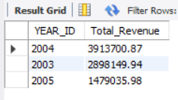
Figure 9: Total revenue by year
Insight: 2004 was the strongest year at $3.91M, ahead of 2003 ($2.90M), while 2005 trails at $1.48M — though this likely reflects a partial year of data rather than a genuine decline (confirmed further in Figure 14).

Query 10: Total Revenue by Month
Business Question
Which calendar months generate the most revenue overall?
SQL Query
SELECT MONTH_ID, SUM(Revenue) AS Total_Revenue
FROM sales_data_sample
GROUP BY MONTH_ID
ORDER BY Total_Revenue DESC;
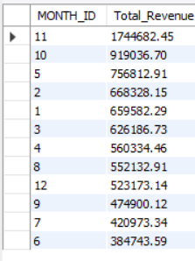
Figure 10: Total revenue by calendar month (aggregated across years)
Insight: November is by far the strongest month ($1.74M), more than 80% higher than the next best month, October ($919K) — a clear seasonal spike, likely tied to holiday-season ordering for a model-vehicle retailer.

8. Order Value and Volume Metrics

Query 11: Average Order Value
Business Question
What is the average value of an order, accounting for the fact that orders contain multiple line items?
SQL Query
SELECT
SUM(SALES) AS total_revenue,
SUM(QUANTITYORDERED) AS total_quantity_sold,
AVG(SALES) AS avg_line_item_value,
SUM(SALES) / COUNT(DISTINCT ORDERNUMBER) AS average_order_value
FROM sales_data_sample;
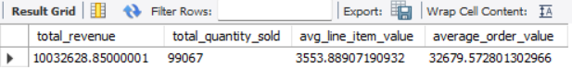
Figure 11: Total revenue, quantity sold, and average order/line values
Insight: While the average line item is worth about $3,553.89, the average full order is worth $32,679.57 — reflecting that each order typically bundles roughly 9 line items together, so per-order value is the more meaningful figure for sales targets.

Query 12: Annual Revenue and Order Volume
Business Question
How do annual revenue and the number of distinct orders trend year over year?
SQL Query
SELECT
YEAR_ID,
SUM(SALES) AS annual_revenue,
COUNT(DISTINCT ORDERNUMBER) AS total_orders
FROM sales_data_sample
GROUP BY YEAR_ID
ORDER BY YEAR_ID;
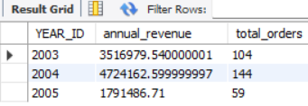
Figure 12: Annual revenue and order count by year
Insight: 2005 shows only 59 orders against 144 in 2004 and 104 in 2003 — a much smaller order count, not just lower revenue — supporting the earlier suspicion that 2005's figures reflect a partial year rather than a real downturn.

Query 13: Monthly Sales Performance Breakdown
Business Question
How does revenue and order count move month-by-month within each year?
SQL Query
SELECT
YEAR_ID,
MONTH_ID,
SUM(SALES) AS monthly_revenue,
COUNT(DISTINCT ORDERNUMBER) AS total_orders
FROM sales_data_sample
GROUP BY YEAR_ID, MONTH_ID
ORDER BY YEAR_ID, MONTH_ID;
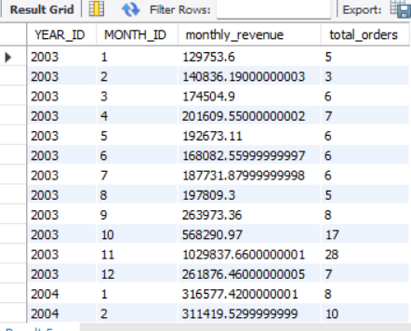
Figure 13: Monthly revenue and order counts (2003 shown, first rows)
Insight: Within 2003 alone, November stands out sharply (28 orders, $1.03M) compared to a fairly flat $130K–$264K across most other months — reinforcing November as a recurring seasonal peak rather than a one-off.

9. Product and Customer Performance

Query 14: Performance by Product Line
Business Question
Which product lines generate the most revenue, items sold, and orders?
SQL Query
SELECT
PRODUCTLINE,
SUM(SALES) AS total_revenue,
SUM(QUANTITYORDERED) AS total_items_sold,
COUNT(DISTINCT ORDERNUMBER) AS unique_orders_count
FROM sales_data_sample
GROUP BY PRODUCTLINE
ORDER BY total_revenue DESC;
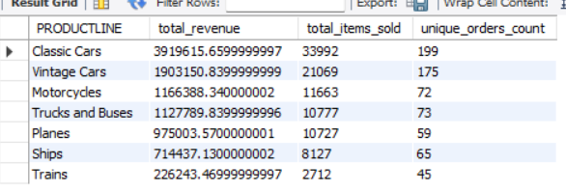
Figure 14: Revenue, items sold, and order count by product line
Insight: Classic Cars is the standout product line, generating $3.92M from 199 orders — more than double the next line, Vintage Cars ($1.90M) — making it the clear flagship category for the business.

Query 15: Top 10 Best-Selling Products by Revenue
Business Question
Which individual products generate the most revenue?
SQL Query
SELECT
PRODUCTCODE,
PRODUCTLINE,
SUM(SALES) AS total_revenue
FROM sales_data_sample
GROUP BY PRODUCTCODE, PRODUCTLINE
ORDER BY total_revenue DESC
LIMIT 10;
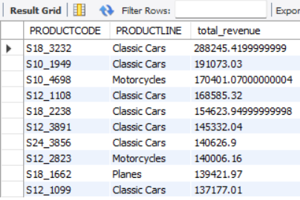
Figure 15: Top 10 individual products by revenue
Insight: Product S18_3232 leads at $288,245.42, and 7 of the top 10 products belong to the Classic Cars line — confirming that the product line's strong performance (Figure 14) is driven by several individually strong SKUs, not just volume.

Query 16: Top 10 High-Value Customers
Business Question
Which customers generate the most revenue, and how often do they purchase?
SQL Query
SELECT
CUSTOMERNAME,
COUNTRY,
SUM(SALES) AS total_customer_spend,
COUNT(DISTINCT ORDERNUMBER) AS purchase_frequency
FROM sales_data_sample
GROUP BY CUSTOMERNAME, COUNTRY
ORDER BY total_customer_spend DESC
LIMIT 10;
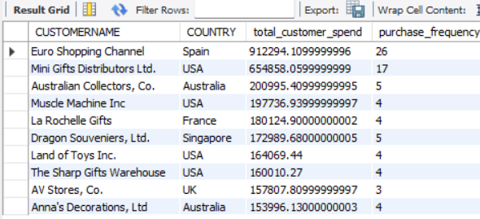
Figure 16: Top 10 customers by total spend and purchase frequency
Insight: Euro Shopping Channel not only spends the most ($912,294.11) but also orders most frequently (26 times) — high spend paired with high frequency makes this a model loyal account worth using as a benchmark for account management.

10. Geographic and Operational Summary

Query 17: Revenue Breakdown by Country
Business Question
What is the full revenue and order-count breakdown across all countries?
SQL Query
SELECT
COUNTRY,
SUM(SALES) AS total_revenue,
COUNT(DISTINCT ORDERNUMBER) AS total_orders
FROM sales_data_sample
GROUP BY COUNTRY
ORDER BY total_revenue DESC;
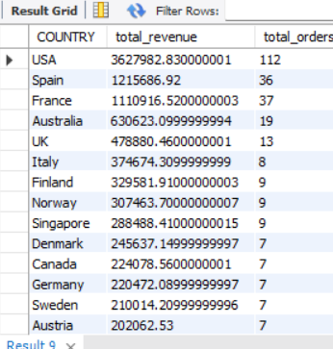
Figure 17: Revenue and order count for all 19 countries (top rows shown)
Insight: The USA accounts for $3.63M in revenue from 112 orders — an average order value of roughly $32,400, broadly in line with the global average order value calculated earlier, suggesting the USA's lead is driven by order volume rather than unusually large individual orders.

Query 18: Order Fulfillment Status
Business Question
Across distinct orders (not line items), how many fall into each fulfillment status, and what is their monetary value?
SQL Query
SELECT
STATUS,
COUNT(DISTINCT ORDERNUMBER) AS total_orders,
SUM(SALES) AS total_monetary_value
FROM sales_data_sample
GROUP BY STATUS
ORDER BY total_orders DESC;
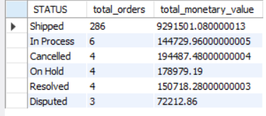
Figure 18: Order count and monetary value by fulfillment status
Insight: 286 of the orders in the dataset are Shipped, representing $9.29M in value, while Cancelled, On Hold, Resolved, and Disputed orders combined account for only 17 orders — confirming a fulfillment success rate above 90% at the order level.

Query 19: Deal Size Distribution
Business Question
How are line items distributed across deal size categories (Small, Medium, Large), and what value does each contribute?
SQL Query
SELECT
DEALSIZE,
COUNT(*) AS line_item_count,
SUM(SALES) AS combined_sales_value
FROM sales_data_sample
GROUP BY DEALSIZE
ORDER BY combined_sales_value DESC;
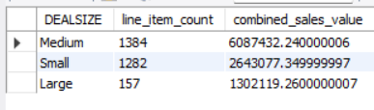
Figure 19: Line item count and combined sales value by deal size
Insight: Medium deals contribute the most combined value ($6.09M from 1,384 line items), while Large deals — despite having the fewest line items (157) — still generate $1.30M, showing Large deals carry a disproportionately high value per line item.

11. Summary of Key Findings
- The dataset covers 2,823 line items rolling up to 307 unique orders, 92 customers, 109 products, and 19 countries, with total revenue of $8,290,886.79.
- The USA is the dominant market on every dimension measured — revenue ($2.99M–$3.63M depending on query), shipped quantity (32,923 units), and order count (112–144) — roughly triple the next-best country, Spain.
- Classic Cars is the flagship product line, generating $3.92M in revenue, more than double the second-place line (Vintage Cars), and supplying 7 of the top 10 individual best-selling products.
- Euro Shopping Channel is the single most valuable customer by both total spend ($766K–$912K depending on query) and purchase frequency (26 orders), making it a benchmark account.
- November is a clear seasonal peak month, generating $1.74M — over 80% more than the second-best month — a pattern that repeats within individual years and likely reflects holiday-season demand.
- Order fulfillment is healthy: over 90% of distinct orders are successfully Shipped, and cancelled/disputed quantities represent under 3% of total shipped volume, though Spain shows the highest friction on both cancellations and disputes.
- 2005's lower revenue and order count appear to reflect a partial year of data rather than a genuine decline, based on the much smaller order count (59) relative to 2003 (104) and 2004 (144).

12. Conclusion
This exercise reinforced core SQL skills required for sales analysis: filtering and sorting with WHERE and ORDER BY, aggregate functions (SUM, AVG, COUNT), conditional aggregation with GROUP BY and HAVING, and multi-dimensional breakdowns combining time, geography, product, and customer attributes. Beyond syntax, each query was tied back to a business question and interpreted for what it reveals about revenue concentration, seasonality, and fulfillment performance — a workflow that mirrors how SQL is used in real sales and business analytics roles.

